# Exercise 2: Implementing Dependency Injection

## Scenario:

In the library management application, you need to manage the dependencies between the BookService and BookRepository classes using Spring's IoC and DI.

## Steps:

1. **Modify the XML Configuration:**
   * Update **applicationContext.xml** to wire **BookRepository** into **BookService**.
2. **Update the BookService Class:**
   * Ensure that **BookService** class has a setter method for **BookRepository**.
3. **Test the Configuration:**
   * Run the **LibraryManagementApplication** main class to verify the dependency injection.

applicationContext.xml –

Explicitly injecting the BookRepository bean into the BookService bean using setter-based dependency injection.

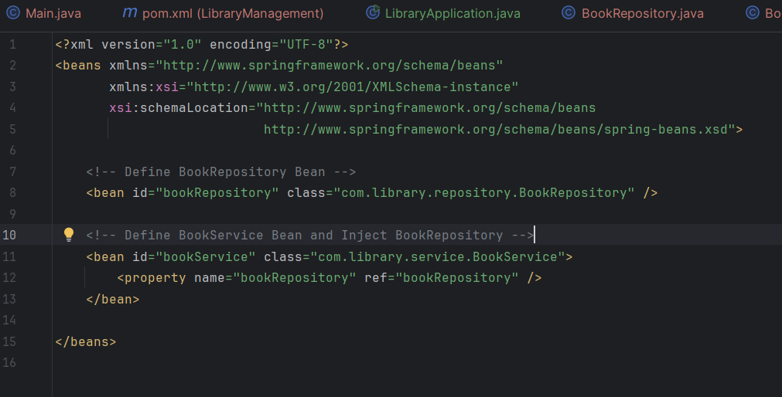

BookService class –

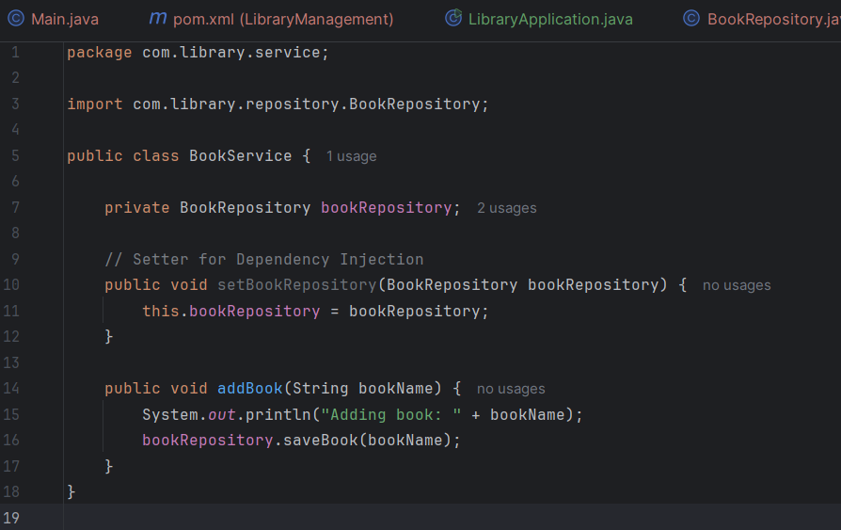

LibraryApplication class –

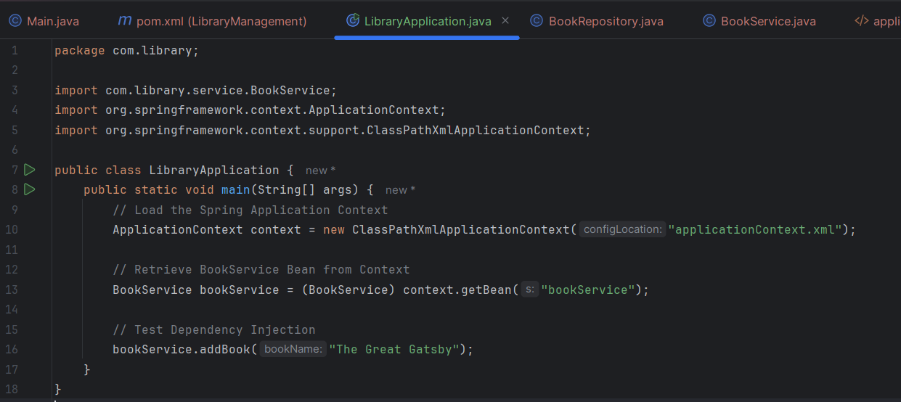

Output –

